|  |  |  |  |
| --- | --- | --- | --- |
| Year 12 Worksheet 1 – Formative Assessment 5 | | | |
|  | | | |
| **Name:** | **Teacher:** | **Score /10** | |
| **Comment:** | | | **Time allowed:**  **10 minutes** |

1. If the distance between two bodies is doubled, the force of attraction F between them will be:
2. 1/4 F
3. 2 F
4. 1/2 F
5. F
6. Which one of the following graphs correctly shows the relationship between the gravitational force, F, between two masses and their separation r:

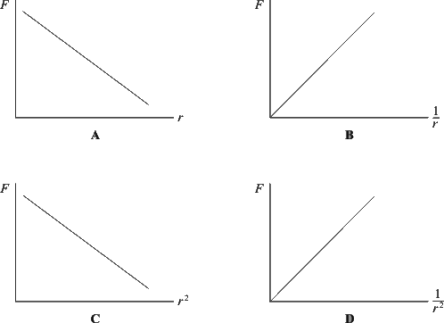

1. In a science fiction story, a planet has half the radius of the Earth, but the same mass as the earth. What is the acceleration due to gravity at the surface of this planet as a function of g?
2. 4g
3. 2g
4. 1 g
5. 1/2 g
6. 1 4 g
7. When calculating gravitational field strength, the correct units to express answers are:
8. ms-2
9. N kg
10. ms-1
11. N kg-1
12. Use the information given in the Formulae and Data Booklet to calculate the orbital period, in seconds, of the Moon around the Earth.

[6 Marks]